Phase transition divert solution for any industries
Application description:
A turbidity meter is installed before a silo and a drain valve. The meter will prevent the product in the silo from being contaminated by water and will also prevent the product from being dumped in waste sewer.
The meter sends a continuous signal to the PLC and the PLC controls the valve according to a preset turbidity point.
Designed for:
-Dairies (3A available)
-food and beverage
-cheese plants
-sugar plants
-Thea plants
-waste water
Milktronics solution
We provide a plug and play solution which includes:
-set of stainless steel SS304 pipes with tri-clamp
-1 turbidity meter with tri-clamp
-1x 3 way divert valve or 2 separate 2 ways valve (customer can choose).
-The turbidity meter can directly control the valve or the valve can be controlled by the PLC.
-The set is assembled in our facility, tested and sent to any customer in NA.

3 way valve system: 2 ways valve system:
Equipment:
Turbidity meter type: VOM 0-10000NTU 24VDC 4-20mA M12
Integrated display (other options are available)
3 ways valve type:
Pipes : stainless steel SS304 with tri-clamps

To get a quote or to order please contact us
Information needed for quotation:
-Diameter of the pipe
-choose between 1x 3way valve or 2 x 2way valve
-outside or inside mounting
-divert controlled by the meter or by the PLC

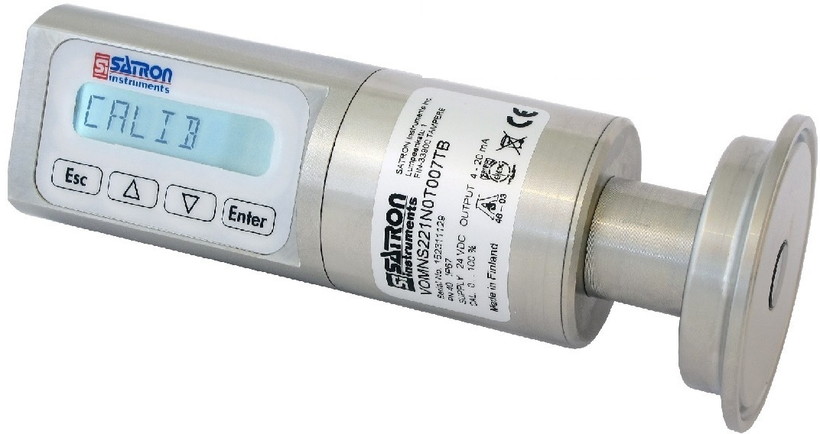
3 way valve
VOM turbidity meter
